Natural Fiber Dyeing Workshop
By Sandra King of the Irish Fibre Guilde (all the way from Balliruan, Ireland)
Hosted by Grove Hill Farm – Old Fort NC
September 25th & 26, 2021 Time: 9 am to 4 pm
Cost $175
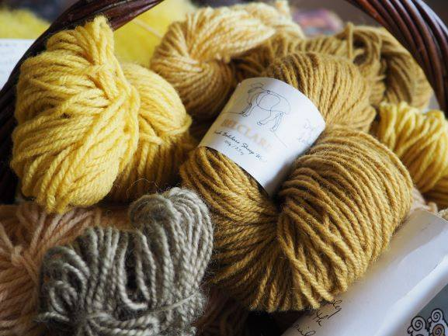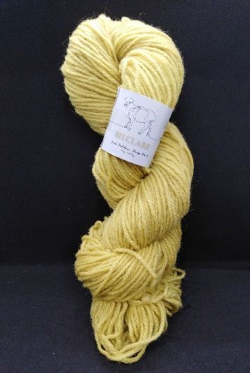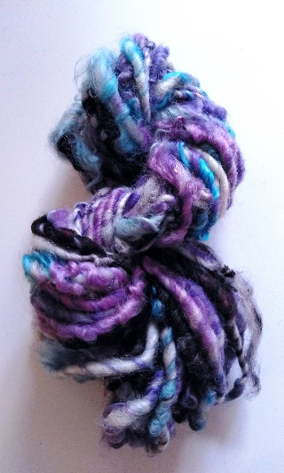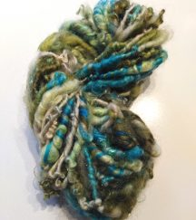
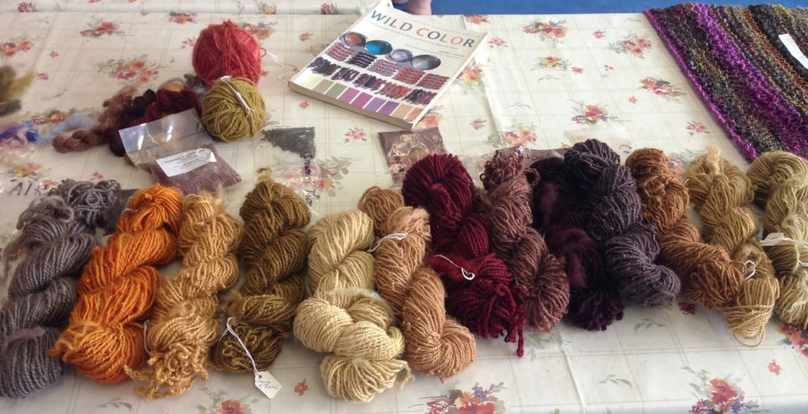
Where: 498 Greenlee Rd Old Fort NC 28762 – 828.925.1598
To register email grovehillpottery@gmail.com or sandra.meetthewool@gmail.com
Visit Grove Hill Pottery or Irish Fibre Crafters on Facebook
Check out Sandra & her workshop on Youtube at https://www.youtube.com/watch?v=HtD666v1lFI
https://mail.google.com/mail/u/0/?pli=1#search/sandra?projector=1

